Ideation Phase
Empathize & Discover

Date | 31 January 2025
Team ID
Project Name
Maximum Marks | 4 Marks

Empathy Map Canvas (Heart Disease Data Analysis Project):
An empathy map is a simple tool that helps the project team understand the users, their needs, and the challenges they face. In this project, it helps the team learn about the problems healthcare professionals and researchers experience while working with heart disease data.
By using an empathy map, the team can understand how users think, the difficulties they face when analyzing large healthcare datasets, and what kind of support they need to make their work easier. It highlights issues such as identifying risk factors, handling complex patient information, and finding meaningful insights from the data.
Understanding the user's point of view helps the team design a better solution. This process supports the development of useful tools like interactive dashboards and visualizations that make heart disease data easier to understand and help improve healthcare decision-making.
Example:
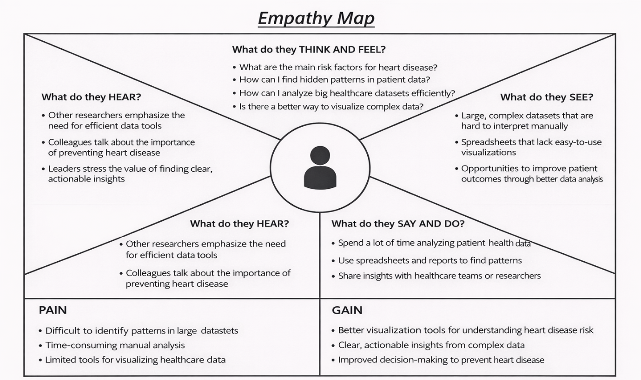

Reference: https://www.mural.co/templates/empathy-map-canvas

Example: Healthcare Professional / Medical Researcher
They work with patient health data and want to understand factors that increase the risk of heart disease.
